**Game Design Document for:**

*Breaking Greg*

All work Copyright ©2018

Written by Team AIE Production

Table of Contents

**1.0 Revision History** **3**

**2.0 Game Overview** **4**

2.1 High Concept 4

2.2 Synopsis 4

○ 2.3 Pillars 5

2.4 Genre 5

2.5 Target Demographic 5

**3.0 Mechanics** **6**

3.1 Movement 7

3.2 Combat 7

3.2 Combo 7

3.3 Win lose state 7

3.4 Score 7

Final Score is calculated at a lose state 7

3.5 Environment Interaction 8

3.6 Rage 8

3.7 Thrown object 8

3.8 Enemies 9

**4.0 Items** **10**

**5.0 Game Flow** **10**

○ 5.1 ‘Mission’ / ‘Level’ structure 11

○ 5.2 Objectives 11

○ 5.2.1 Optional objectives 11

**6.0 Story and Characters** **12**

○ 6.1 Characters 12

○ 6.2 Storyline 12

**7.0 Levels** **13**

7.1 Level(s) 13

■ 7.1.1 Features 13

■ 7.1.2 Aesthetic/setting 13

**8.0 Interface** **16**

○ 8.1 GUI Elements 17

■ 8.1.1 HUD 17

■ 8.1.2 Menus 19

○ 8.2 Camera 19

○ 8.3 Controls 20

**9.0 Visualization** **22**

■ 9.2 References 22

■ 9.3 Lighting 22

■ 9.4 Pipeline 22

Characters: 22

● Modular assets allowing for a range of NPC varients within the levels 22

**10.0 Release Details** **23**

10.1 Editor/Engine 23

10.2 Platforms 23

10.3 System Requirments 23

10.4 Business Model 23

**11.0 Sound** **24**

○ 11.1 Music 24

○ 11.2 SFX list 24

# 1.0 Revision History

| Version | Description |
| --- | --- |
| 1.0 | Initial document |
| 1.1 | Started Game Overview, Mechanics and Interface |
| 1.2 | Added list Items, added Game Flow diagram, added sound list, added more to Mechanics, added SFX list. |
| 1.3 | Added more to Mechanics, added more info to Levels, added Interface flowchart, added HUD templates, added Isometric camera diagram, added to Menus and added Controls. |
| 1.4 | Added diagram to controls, Fixed diagram for Game Flow, Added to story, adjusted formatting and added watermark. |
| 2.0 | Second Round revision tidying up document |

# 

# 2.0 Game Overview

## 2.1 High Concept

Isometric office set hack & Slash. Physics based combat causing Environmental destruction & High impact violence. Cause destruction across the level in an attempt to cause maximum collateral damage for HR to deal with.

## 2.2 Synopsis

**USPs**

* Fluid combat system
* Score Modifiers
* Repeatable Artist assisted random levels
* Special abilities
* Theme (corporate oppression, 1984, 9-5, propaganda)

## 2.3 Pillars

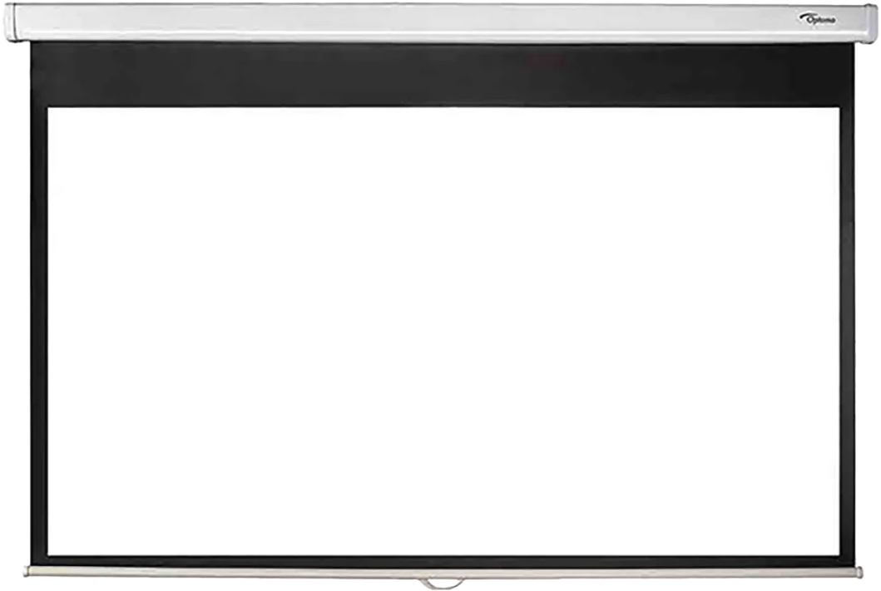

| **Satisfying Player Feedback** | **Ironic Premic** | **Fast paced combat** |
| --- | --- | --- |
| **Majority of environment is interactable in someway**  **Environmental destruction**  **Over the top violence** | **Common fantasy of the everyday office worker**  **Juxtaposition of high impact violence set in a calm corporate office** | **Combo system**  **Simple & Repeating animations**  **Special abilities** |

## 

## 2.4 Genre

* Hack and Slash genre which will be used to emphasize the combat with melee based weapons (fists). Will also feature projectile based weapons (intractable throwable props). The camera will be from an isometric view point which is representing 3 dimensional assets in a 2 dimensional space

## 2.5 Target Demographic

* 15+ (High cartoon violence)
* Casual gamer
* Highly replayable experience from random level generation
* Competitive elements from score system

# 3.0 Mechanics

## 3.1 Movement

* *Player can move using 360 Degree Run*
* *Idle state*

## 3.2 Combat

***Light Attack (Punch)***

* *Basic punch attack hitting all enemies in front of the player at a moderately fast speed*

***Heavy Attack (Slam)***

* *AOE damage all around the player rather than in a particular direction*
* *Stuns large enemies to open them up to take damage*

***Combo Multiplier***

* *Consecutive landed hits on both people*
* *Combo breaks when the player is hit or misses an attack*

***Throwables***

* *Medium objects can be picked up and thrown to deal damage to enemies*
* *Break on impact*
* *Refer to 3.7*

## 3.2 Combo

* No effect on Combat
  + A score modifier & Player feedback system
    - Increased by consistently land hits & killing people
    - If the player has not killed someone in “x” seconds combo modifier is reset to 0
* **Example**:
  + x5 combo is +5% score of initial value
  + x37 combo is +37% of initial value

## 3.3 Win lose state

*Win - getting to the next level*

*Lose - police getting called, rage meter getting to 0*

## 3.4 Score

## Final Score is calculated at a lose state

***Gain score by:***

* *Destroying objects*
* *Killing people which can be increased through the combo system*
* *Gain incremental score bonus through going up a levels*
* *Time spent in a level depreciates total level score (longer player spends less score is gained from level*

## 3.5 Environment Interaction

**Destructible Objects**

Large Objects are broken when hit by player or props

* Medium props break into pieces after being hit

**Vending Machines**

* + Players can interact with vending machines to get a brief speed boost
  + Vending machines are one use and will break after use

**Throwables**

* + Medium sized objects can be picked up and thrown and break on impact

## 3.6 Rage

* Rage depleats overtime during gameplay but goes up when the player kills NPCs
* When rage is full the player can press **SPACEBAR** to activate *“chaos mode”*
  + During *“chaos mode”* time slows but the player stays at normal speed
  + Rage stays full during chaos
  + when “*chaos mode”* finishes rage meter is reduced to half full

**Lose state:**

* When rage is empty the player loses

## 3.7 Thrown object

* + Lifetime on throwables to always break after a distance

Differ object to object

* + Object travel through enemies for collaterals
  + Different objects have different sized hit boxes for AOE

## 3.8 Enemies

**Genetic NPC’s :**

non-combative

**Navigation states:**

* Runs away to random point
* Running to hide
* Running to telephone (specific meshes as identifying them as important)

**Death requirements:**

* Requires 1 hit to kill

**Score rewarded:**

* Final score value: 100

**Tough Guy NPC’s :**

combative

**Navigation states:**

* Running towards the player

**Combat Requirments:**

* Require a Stun to be damaged

(Throwing an object at them, or special ability)

**Death requirements:**

* Require 3 hits to kill

**Score rewarded:**

* Initial score value: 300
* each hit adds to combo

# 4.0 Items

| **Item** | **Throwable** | **Breakable** | **Physics** | **Effects** |
| --- | --- | --- | --- | --- |
| *Medium Prop* | Yes | Not Until Thrown | Yes | Deals Damage |
| *Vending machine* | No | After being interacted with | No | Speed Boost |

# 5.0 Game Flow

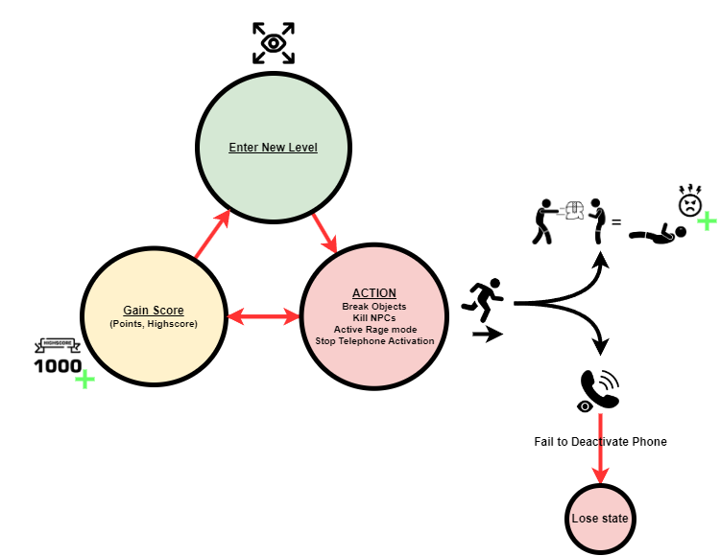

## 5.1 ‘Mission’ / ‘Level’ structure

* *Level to level progression*
* *Each floor will be progressing with incremental difficulty*
  + - *Difficulty modifiers:*
      * *NPC speed*
      * *NPC stun time*

## 5.2 Objectives

***Primary Objective:***

1. *Getting to as highest a floor as possible*
2. *Causing as much monetary damage to the company as possible*
   * *Each object has a cost value which is added to a score counter*
3. *Killing Office workers*
   * *upkeeping the rage filled*

***Secondary Objective:***

1. *Stopping NPC’s from getting to telephones*
   * NPC’s call police to subdue the player
   * Causes a timer to begin counting down
   * Telephone countdown continues until phone call is complete causing the player to lose or the call is interrupted by the player causing the countdown to cancel.

## 5.2.1 Optional objectives

***Easter Eggs:***

1. *Discovery of easter eggs spread across all the levels*

# 6.0 Story and Characters

## 6.1 Characters

**Main Character (Player character)**

* Greg is a regular office worker living a depressing life which seems to have fallen apart leading him to off the rails, and “Break”

**NPC’s (generic office workers)**

* The faceless mass of employs at the unnamed company greg works for, terrified by gregs rage all they can do to escape is dial 911 at telephones in set locations around the level and hope the police arrive in time!

**NPC’s (Tough guy office workers)**

* They’re the heroes of the mundane office need but do not deserve. who have taken up arms in the face of greg to take him down, but this is a loosing battle, nothing can stop greg in his tracks, only slow him down…

## 6.2 Storyline

**A dark day at the office**

* *Greg’s miserable life has been going wrong for as long as he can remember.*
* *Fardux coffee workers have gone on strike due to low wages, and awful working conditions. his wife cheated on him, after never having enough time for her, his liberal arts degree has not taken him to the hights he once foresaw, his parents hate him for never calling, His only friend goldie has just died, a becon of hope in his life sniffed out far too soon floats upsidedown lifelessly next to him. and worst of all; his rent just went up, Again!*
* *Gregs pent up rage has finally tipped over its boiling point and he can hold it in now longer, today is the day.*
* *Greg throws his company issued productivity pills to the floor, standing up strong flipping his plastawood desk on its head, spilling his cramped office cubicbles content all over the drab cream floor.*
* *Greg is seeing red, overcome with a blind anamalistic rage in which only blood can quench.*
* *Nothing can stop him now, the adrenaline pumping like oil through his veins.*
* *No man, woman, obstacle or productivity supivoror can stand in his way now.*
* *His only goal, Cause as much damage as possible regardless of the consequences.*

# 7.0 Levels

## 7.1 Level(s)

* *“To be determined amount” levels are designed and created then randomly picked from a list for the and as the player progresses levels rise in difficulty.*
* *This is a goal as there will only be 5 milestones that change visual differences of NPC’s*
* *The game is endless, so player can make it as far as their skills will take them.*

### 7.1.1 Features

* *Telephones are spawned in special rooms within the level,* 
  + *Allowing NPCs to Call the authorities on greg, causing the loose state.*
* *Milestone Difficulty changes (Changes every 10 rounds)*
  + *Amount of hits to kill stunable enemies (3 to 4 eg)*
  + *Visuals of stunning enemies*
* *Ramping difficulty (Changes every round)*
  + *NPC movement speed*
  + *Stun duration*
  + *Amount of telephone NPCs*
  + *Amount of buff guy NPCs*

### 7.1.2 Aesthetic/setting

**Theme (Key stylistic references):**

* 1984 (Company opression)
* Drab decor
* Faceless worker drones

***Setting:***

* Corporate office

***Time period:***

* *1990’s- Early 2000’s*

| ***Environment*** |  |  |
| --- | --- | --- |
|  |  |  |
|  |  |  |

| ***Character*** |
| --- |
|  |

# 8.0 Interface

|  |
| --- |
| **Main Menu flowchart** |

## 8.1 GUI Elements

### 8.1.1 HUD

|  |
| --- |
| ***Rage Meter*** |
|  |
| ***Combo Multiplier*** |
|  |
| ***Phone alert Icon / Countdown visualisation*** |
|  |
| ***Score ($ damage caused)*** |
|  |
| ***Highscores*** |

### 8.1.2 Menus

* ***Menu (Diegetic system)***
  + Start: When clicked will load game level.
  + Controls: Will open a page with an image of control scheme.
  + Exit: Will close game.
* ***Pause Menu***
  + Resume: Will unpause the game.
  + Controls: Will open a page with an image of control scheme.
  + Exit to main menu: Will leave the level and will open main menu.

## 8.2 Camera



*Isometric camera angle, focusing in the players view to a limited section of the level, to encourage exploration*

## 8.3 Controls

* ***Keyboard & Mouse***

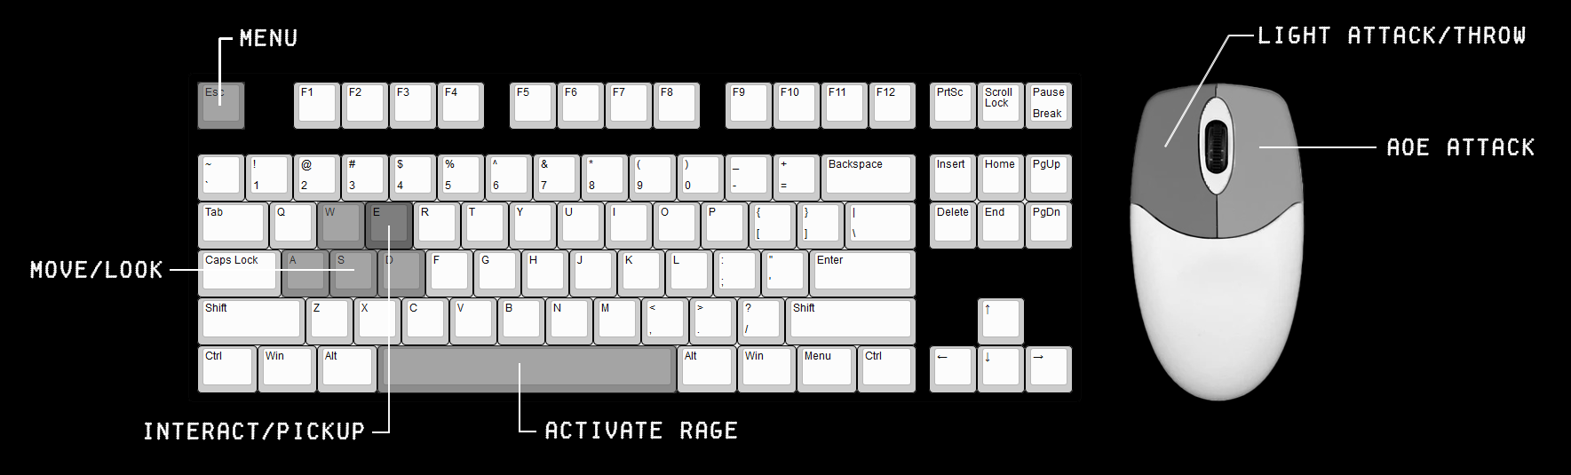

* *Menu:* ***Esc***
* *Menu Navagate:* ***Mouse***
* *Light Attack/Throw:* ***LMB***
* *AOE Attack:* ***RMB***
* *Move/look:* ***WASD***
* *Activate Rage:* ***Spacebar***
* *Interact/Pickup:* ***E***

***Controller***

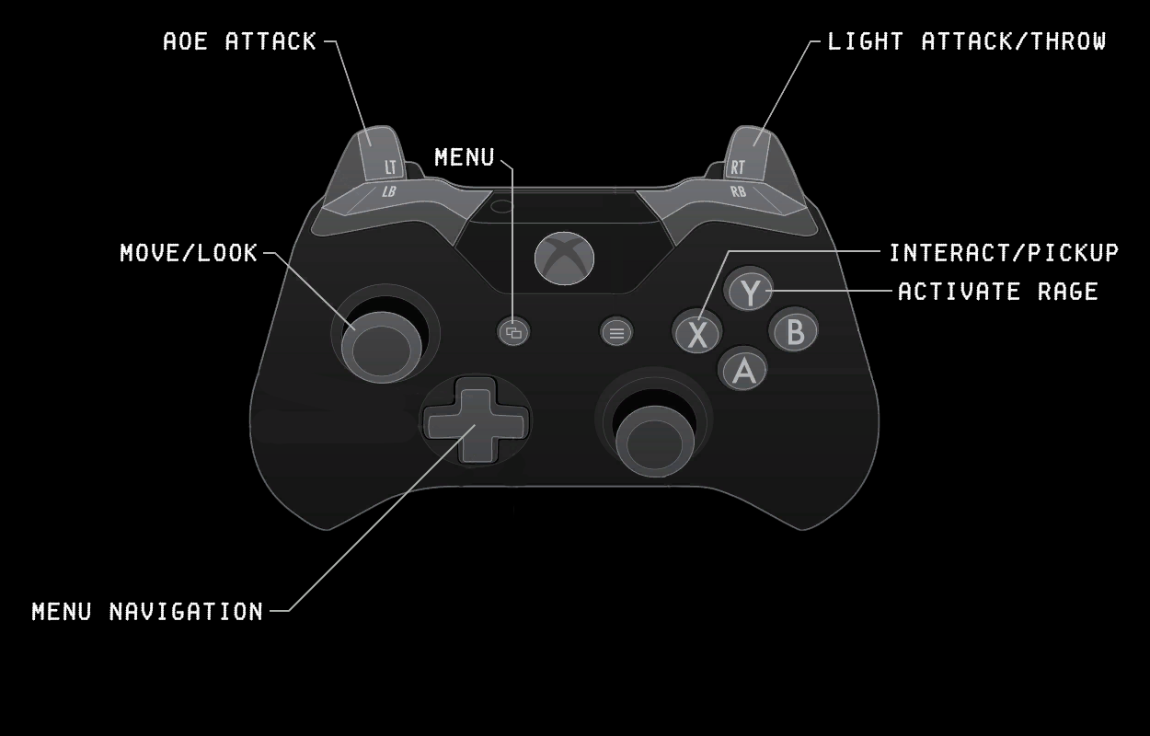

* *Menu:* ***View button***
* *Menu Navagate:* ***D-pad/Right stick***
* *Light Attack/Throw:* ***RT***
* *AOE Attack:* ***LT***
* *Move/look:* ***Left stick***
* *Activate Rage:* ***Y***
* *Interact/Pickup:* ***X***

# 9.0 Visualization

**9.1 Art Style and Aesthetic**

* *Refer to the Art Style Guide*

## 9.2 References

* + *Refer to ArtBible*

## 9.3 Lighting

* + *Refer to ArtBible*

## 9.4 Pipeline

## **Characters:**

## Modular assets allowing for a range of NPC varients within the levels

* Male & Female rigs

**Destrutible props:**

* Split into 3 categories ( Large, Medium, and Small)
* 2 Varients of Large/ Medium Models (Original, Broken)

**Level construction:**

* Generate initial layout using script to give artist(s) a base level to work from
* Artists go back over levels for a detail & level design pass to create a set of levels for the game to randomly pick from each time the player advances to the next level.

# 10.0 Release Details

## 10.1 Editor/Engine

* *Unity, 2020.3.5f1*

## 10.2 Platforms

* *PC ( both keyboard + mouse, and controller support)*

## 10.3 System Requirments

* OS: Windows 7/8.1/10 (32-bit)
* CPU: Quad-Сore 2.5 GHz
* RAM (memory): 8 GB
* Videocard: NVIDIA GeForce 470 GTX/AMD Radeon 6870 HD
* HDD: 1 GB
* DirectX: 11

## 10.4 Business Model

* *One Time purchase, $12.99 AUD*

# 11.0 Sound

## 11.1 Music

| ***Name:*** | ***Use:*** | ***Reference:*** |
| --- | --- | --- |
| Elevator music 1 | When the player first enters a room and has not caused any chaos. | <https://www.youtube.com/watch?v=xy_NKN75Jhw&ab_channel=GamingSoundFX> |
| Elevator music 2 | Plays during Loading screen. | <https://www.youtube.com/watch?v=VBlFHuCzPgY&ab_channel=AntoineB> |
| Office ambience & Elevator music 1 | Used for Main Menu | <https://www.youtube.com/watch?v=I0qpNCg4rMo&t=24s&ab_channel=AmbienceHub>  <https://www.youtube.com/watch?v=xy_NKN75Jhw&ab_channel=GamingSoundFX> |

## 11.2 SFX list

| ***Name:*** | ***Use:*** | ***Reference:*** |
| --- | --- | --- |
| Walk | NPC and Aggressive NPC | <https://www.youtube.com/watch?v=SBKUv4YqrG4&ab_channel=HQSounds> |
| Run | Player, NPC and Aggressive NPC | <https://www.youtube.com/watch?v=85MlyOJUnag&ab_channel=HQSounds> |
| Punch impact | Player and Aggressive NPC. | <https://www.youtube.com/watch?v=OFN2yOLuqB0&ab_channel=PlaySounds> |
| Punch Swing | Player and Aggressive NPC. | <https://www.youtube.com/watch?v=3Gda_f9BsXI&ab_channel=TheMathewFlames> |
| Breaking sounds for medium objects | When objects are interacted and break. | <https://www.soundsnap.com/user/6460857/favorites/274660> |
| Phone Ring | When NPC uses the phone. | <https://www.soundsnap.com/phone_standard_ring_x2> |
| NPC Grunts/Screen | When an NPC takes damage. | <https://www.soundsnap.com/male3_hurt2> |
| NPC Dialog | When an NPC takes damage. | <https://www.soundsnap.com/male_voice_yelling_stop_and_crying> |
| Phone interrupt | When the player kills NPC before cops are called. | <https://www.soundsnap.com/mobile_phone_key_tone_off>  <https://www.soundsnap.com/emergency_police_dispatch_radio_int_car_adult_male_disregard_the_call_01> |
| Police call timer ends | When the NPC finishes calling the cops. | <https://www.soundsnap.com/interior_car_police_radio_dispatch_young_man_says_transport_is_on_the_way_blastwavefx_11218> |